SEC Form 4

FORM 4

Check this box if no longer subject to Section 16. Form 4 or Form 5 obligations may continue. See Instruction 1(b).

UNITED STATES SECURITIES AND EXCHANGE COMMISSION
Washington, D.C. 20549
 |  | OMB APPROVAL
STATEMENT OF CHANGES IN BENEFICIAL OWNERSHIP
 |  | OMB Number: | 3235-0287
 |  | Estimated average burden
Filed pursuant to Section 16(a) of the Securities Exchange Act of 1934 |  | hours per response: | 0.5
or Section 30(h) of the Investment Company Act of 1940
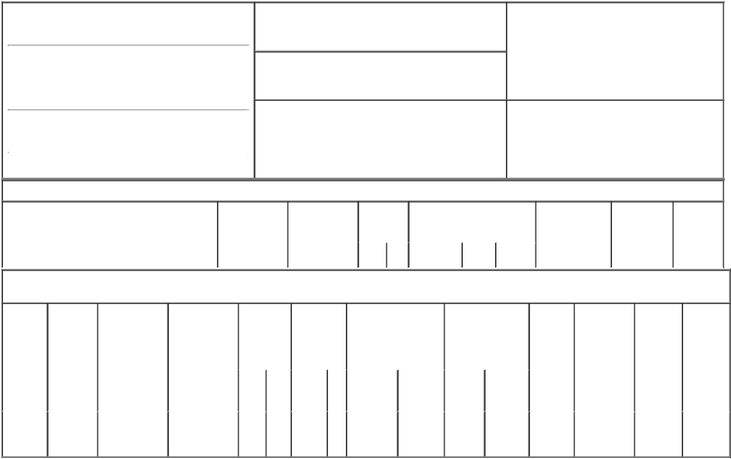

1. Name and Address of Reporting Person*
Apelian David

(Last) (First) (Middle)

C/O EIGER BIOPHARMACEUTICALS, INC.

2155 PARK BLVD.

2. Issuer Name and Ticker or Trading Symbol
Eiger BioPharmaceuticals, Inc. [ EIGR ]

3. Date of Earliest Transaction (Month/Day/Year)

01/31/2023

- Relationship of Reporting Person(s) to Issuer (Check all applicable)

X | Director | 10% Owner
X | Officer (give title | Other (specify
 | below) | below)

Interim CEO

(Street)
 | PALO ALTO | CA | 94306
 | (City) | (State) | (Zip)

4. If Amendment, Date of Original Filed (Month/Day/Year) 6. Individual or Joint/Group Filing (Check Applicable

Line)
X Form filed by One Reporting Person

Form filed by More than One Reporting

Person

Table I - Non-Derivative Securities Acquired, Disposed of, or Beneficially Owned

1. Title of Security (Instr. 3) | 2. Transaction | 2A. Deemed | 3. | 4. Securities Acquired (A) or |  |  | 5. Amount of | 6. Ownership | 7. Nature of
 | Date | Execution Date, | Transaction | Disposed Of (D) (Instr. 3, 4 and 5) |  |  | Securities | Form: Direct | Indirect
 | (Month/Day/Year) | if any | Code (Instr. |  |  |  | Beneficially | (D) or Indirect | Beneficial
 |  | (Month/Day/Year) | 8) |  |  |  | Owned Following | (I) (Instr. 4) | Ownership
 |  |  |  |  |  |  | Reported |  | (Instr. 4)
 |  |  | Code V | Amount | (A) or | Price | Transaction(s)
 |  |  |  |  | (D) |  | (Instr. 3 and 4)

Table II - Derivative Securities Acquired, Disposed of, or Beneficially Owned

(e.g., puts, calls, warrants, options, convertible securities)

1. Title of | 2. | 3. Transaction | 3A. Deemed | 4. | 5. Number of |  | 6. Date Exercisable and |  | 7. Title and Amount |  | 8. Price of | 9. Number of | 10. | 11. Nature
Derivative | Conversion | Date | Execution Date, | Transaction | Derivative |  | Expiration Date |  | of Securities |  | Derivative | derivative | Ownership | of Indirect
Security | or Exercise | (Month/Day/Year) | if any | Code (Instr. | Securities |  | (Month/Day/Year) |  | Underlying |  | Security | Securities | Form: | Beneficial
(Instr. 3) | Price of |  | (Month/Day/Year) | 8) | Acquired (A) |  |  |  | Derivative Security |  | (Instr. 5) | Beneficially | Direct (D) | Ownership
 | Derivative |  |  |  | or Disposed |  |  |  | (Instr. 3 and 4) |  |  | Owned | or Indirect | (Instr. 4)
 | Security |  |  |  | of (D) (Instr. |  |  |  |  |  |  | Following | (I) (Instr. 4)
 |  |  |  |  | 3, 4 and 5) |  |  |  |  |  |  | Reported
 |  |  |  |  |  |  |  |  |  |  |  | Transaction(s)
 |  |  |  |  |  |  |  |  |  | Amount |  | (Instr. 4)
 |  |  |  |  |  |  |  |  |  | or
 |  |  |  |  |  |  | Date | Expiration |  | Number
 |  |  |  | Code V | (A) | (D) | Exercisable | Date | Title | of Shares
Stock
Option | $1.65 | 01/31/2023 |  | A | 170,000 |  | (1) | 01/31/2033 | Common | 170,000 | $0 | 170,000 | D
(Right to |  |  |  |  |  |  |  |  | Stock
Buy)

Explanation of Responses:

- The option vests as to 113,900 shares upon the earlier to occur of (i) on the six-month anniversary of December 14, 2022 or (ii) the Company's appointment of a full-time non-interim Chief Executive Officer, and as to the remaining 56,100 shares in six equal monthly installments measured from December 14, 2022, subject to the Reporting Person's continuous service as of each such date.

/s/ David Apelian |  | 02/02/2023
** Signature of Reporting Person |  | Date

Reminder: Report on a separate line for each class of securities beneficially owned directly or indirectly.

* If the form is filed by more than one reporting person, see Instruction 4 (b)(v).

- Intentional misstatements or omissions of facts constitute Federal Criminal Violations See 18 U.S.C. 1001 and 15 U.S.C. 78ff(a). Note: File three copies of this Form, one of which must be manually signed. If space is insufficient, see Instruction 6 for procedure.
Persons who respond to the collection of information contained in this form are not required to respond unless the form displays a currently valid OMB Number.

