SEC Form 4

FORM 4

Check this box if no longer subject to Section 16. Form 4 or Form 5 obligations may continue. See Instruction 1(b).

UNITED STATES SECURITIES AND EXCHANGE COMMISSION
Washington, D.C. 20549
 |  | OMB APPROVAL
STATEMENT OF CHANGES IN BENEFICIAL OWNERSHIP
 |  | OMB Number: | 3235-0287
 |  | Estimated average burden
Filed pursuant to Section 16(a) of the Securities Exchange Act of 1934 |  | hours per response: | 0.5
or Section 30(h) of the Investment Company Act of 1940
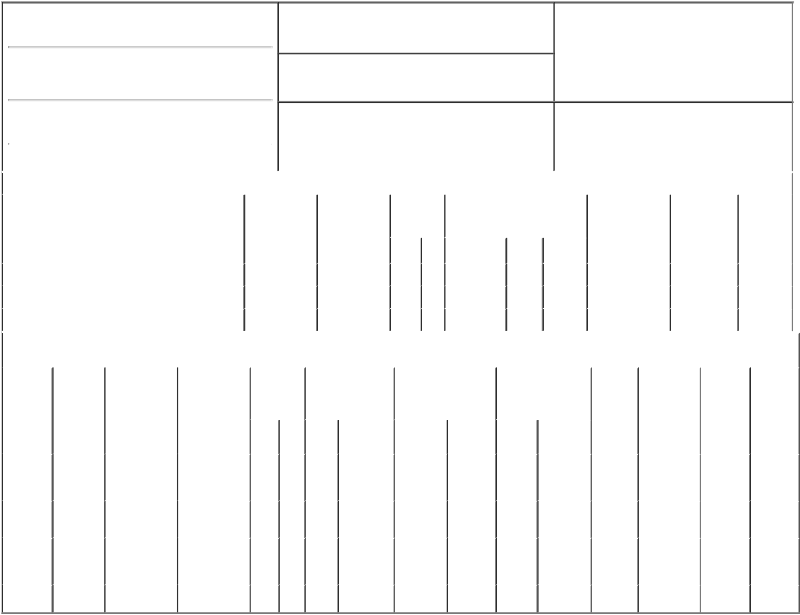

1. Name and Address of Reporting Person*
PFIZER INC

(Last) (First) (Middle)

235 E. 42ND STREET

2. Issuer Name and Ticker or Trading Symbol

Celladon Corp [ CLDN ]

3. Date of Earliest Transaction (Month/Day/Year)

02/04/2014

- Relationship of Reporting Person(s) to Issuer (Check all applicable)

Director X 10% Owner

Officer (give title Other (specify
below) below)

 | (Street) |  |  |  |  |  |  |  | 4. If Amendment, Date of Original Filed (Month/Day/Year) |  |  |  |  |  | 6. Individual or Joint/Group Filing (Check Applicable Line)
 |  | NEW YORK |  | NY |  | 10017 |  |  |  |  |  |  |  |  | X |  | Form filed by One Reporting Person
 |  |  |  |  |  |  |  |  |  |  |  |  |  |  |  |  | Form filed by More than One Reporting Person
 |  | (City) |  | (State) |  | (Zip)
 |  |  |  |  |  | Table I - Non-Derivative Securities Acquired, Disposed of, or Beneficially Owned
 | 1. Title of Security (Instr. 3) |  |  |  |  |  | 2. Transaction |  |  |  | 2A. Deemed | 3. | 4. Securities Acquired (A) or |  |  | 5. Amount of |  |  | 6. Ownership |  | 7. Nature of
 |  |  |  |  |  |  | Date |  |  |  | Execution Date, | Transaction | Disposed Of (D) (Instr. 3, 4 and 5) |  |  | Securities |  |  | Form: Direct |  | Indirect
 |  |  |  |  |  |  | (Month/Day/Year) |  |  |  | if any | Code (Instr. |  |  |  | Beneficially Owned |  |  | (D) or Indirect |  | Beneficial
 |  |  |  |  |  |  |  |  |  |  | (Month/Day/Year) | 8) |  |  |  | Following Reported |  |  | (I) (Instr. 4) |  | Ownership
 |  |  |  |  |  |  |  |  |  |  |  |  |  |  |  | Transaction(s) |  |  |  |  | (Instr. 4)
 |  |  |  |  |  |  |  |  |  |  |  | Code V | Amount | (A) or | Price | (Instr. 3 and 4)
 |  |  |  |  |  |  |  |  |  |  |  |  |  | (D)
 | Common Stock |  |  |  |  |  | 02/04/2014 |  |  |  |  | C | 1,544,397 | A | (1) | 1,544,397 |  |  |  | D
 | Common Stock |  |  |  |  |  | 02/04/2014 |  |  |  |  | C | 23,145⁽²⁾ | A | $8 | 1,567,542 |  |  |  | D
 | Common Stock |  |  |  |  |  | 02/04/2014 |  |  |  |  | P | 227,261⁽³⁾ | A | $8 | 1,794,803 |  |  |  | D
 |  |  |  |  |  | Table II - Derivative Securities Acquired, Disposed of, or Beneficially Owned
 |  |  |  |  |  |  | (e.g., puts, calls, warrants, options, convertible securities)
 | 1. Title of |  | 2. |  | 3. Transaction | 3A. Deemed | 4. |  |  | 5. Number of |  | 6. Date Exercisable and |  | 7. Title and Amount of |  |  | 8. Price of | 9. Number of |  | 10. |  | 11. Nature
 | Derivative |  | Conversion |  | Date | Execution Date, |  | Transaction |  | Derivative Securities |  | Expiration Date |  | Securities Underlying |  |  | Derivative | derivative |  | Ownership |  | of Indirect
 | Security |  | or Exercise |  | (Month/Day/Year) | if any |  | Code (Instr. |  | Acquired (A) or |  | (Month/Day/Year) |  | Derivative Security |  |  | Security | Securities |  | Form: |  | Beneficial
 | (Instr. 3) |  | Price of |  |  | (Month/Day/Year) | 8) |  |  | Disposed of (D) |  |  |  | (Instr. 3 and 4) |  |  | (Instr. 5) | Beneficially |  | Direct (D) |  | Ownership
 |  |  | Derivative |  |  |  |  |  |  | (Instr. 3, 4 and 5) |  |  |  |  |  |  |  | Owned |  | or Indirect |  | (Instr. 4)
 |  |  | Security |  |  |  |  |  |  |  |  |  |  |  |  |  |  | Following |  | (I) (Instr. 4)
 |  |  |  |  |  |  |  |  |  |  |  |  |  |  | Amount or |  |  | Reported
 |  |  |  |  |  |  |  |  |  |  |  | Date | Expiration |  | Number of |  |  | Transaction(s)
 |  |  |  |  |  |  |  | Code V |  | (A) | (D) | Exercisable | Date | Title | Shares |  |  | (Instr. 4)
 | Series A-1
 | Convertible |  | (1) |  | 02/04/2014 |  |  | C |  |  | 19,289,531⁽¹⁾ | (1) | (1) | Common | 1,544,397 | $0.00 |  | 0 |  | D
 | Preferred |  |  |  |  |  |  |  |  |  |  |  |  | Stock
 | Stock
 | Convertible |  | _{$8}(2) |  |  |  |  |  |  |  |  | (2) | (2) | Common | 23,145
 | Promissory |  |  |  | 02/04/2014 |  |  | C |  |  | 23,145 |  |  |  |  | $8 |  | 0 |  | D
 |  |  |  |  |  |  |  |  |  |  |  |  |  | Stock
 | Notes
 | Series A-1 |  |  |  |  |  |  |  |  |  |  |  |  | Series A-
 |  |  |  |  |  |  |  | _{C}(4) |  |  |  |  |  | 1 | 532,818
 | Preferred |  | $0.449 |  | 02/04/2014 |  |  |  |  |  | 532,818 | 10/15/2013 | 10/15/2018 |  |  | $0.00 |  | 0 |  | D
 | Warrants |  |  |  |  |  |  |  |  |  |  |  |  | Preferred
 |  |  |  |  |  |  |  |  |  |  |  |  |  | Stock
 | Common |  | $5.61 |  | 02/04/2014 |  |  | _{C}(4) |  | 42,659 |  | 10/15/2013 | 10/15/2018 | Common | 42,659 | $0.00 |  | 42,659 |  | D
 | Warrants |  |  |  |  |  |  |  |  |  |  |  |  | Stock

Explanation of Responses:

- Every 12.49 shares of Series A-1 Preferred Stock automatically converted into 1 share of Common Stock without payment of further consideration upon the closing of the Issuer's initial public offering. The shares have no expiration date.

- Automatic conversion, in connection with the Issuer's initial public offering, of convertible promissory notes, including principal and accrued interest.

- The shares were purchased at the Issuer's initial public offering.

- Represents the automatic conversion of Series A-1 Preferred Warrants into Common Stock Warrants on a 1-for-12.49 basis upon the closing of the Issuer's initial public offering.

Remarks:

/s/ Susan Grant, Assistant |  |  |  | 02/06/2014
Secretary on behalf of Pfizer Inc.
** Signature of Reporting Person |  |  | Date

Reminder: Report on a separate line for each class of securities beneficially owned directly or indirectly.

* If the form is filed by more than one reporting person, see Instruction 4 (b)(v).

- Intentional misstatements or omissions of facts constitute Federal Criminal Violations See 18 U.S.C. 1001 and 15 U.S.C. 78ff(a). Note: File three copies of this Form, one of which must be manually signed. If space is insufficient, see Instruction 6 for procedure.
Persons who respond to the collection of information contained in this form are not required to respond unless the form displays a currently valid OMB Number.

